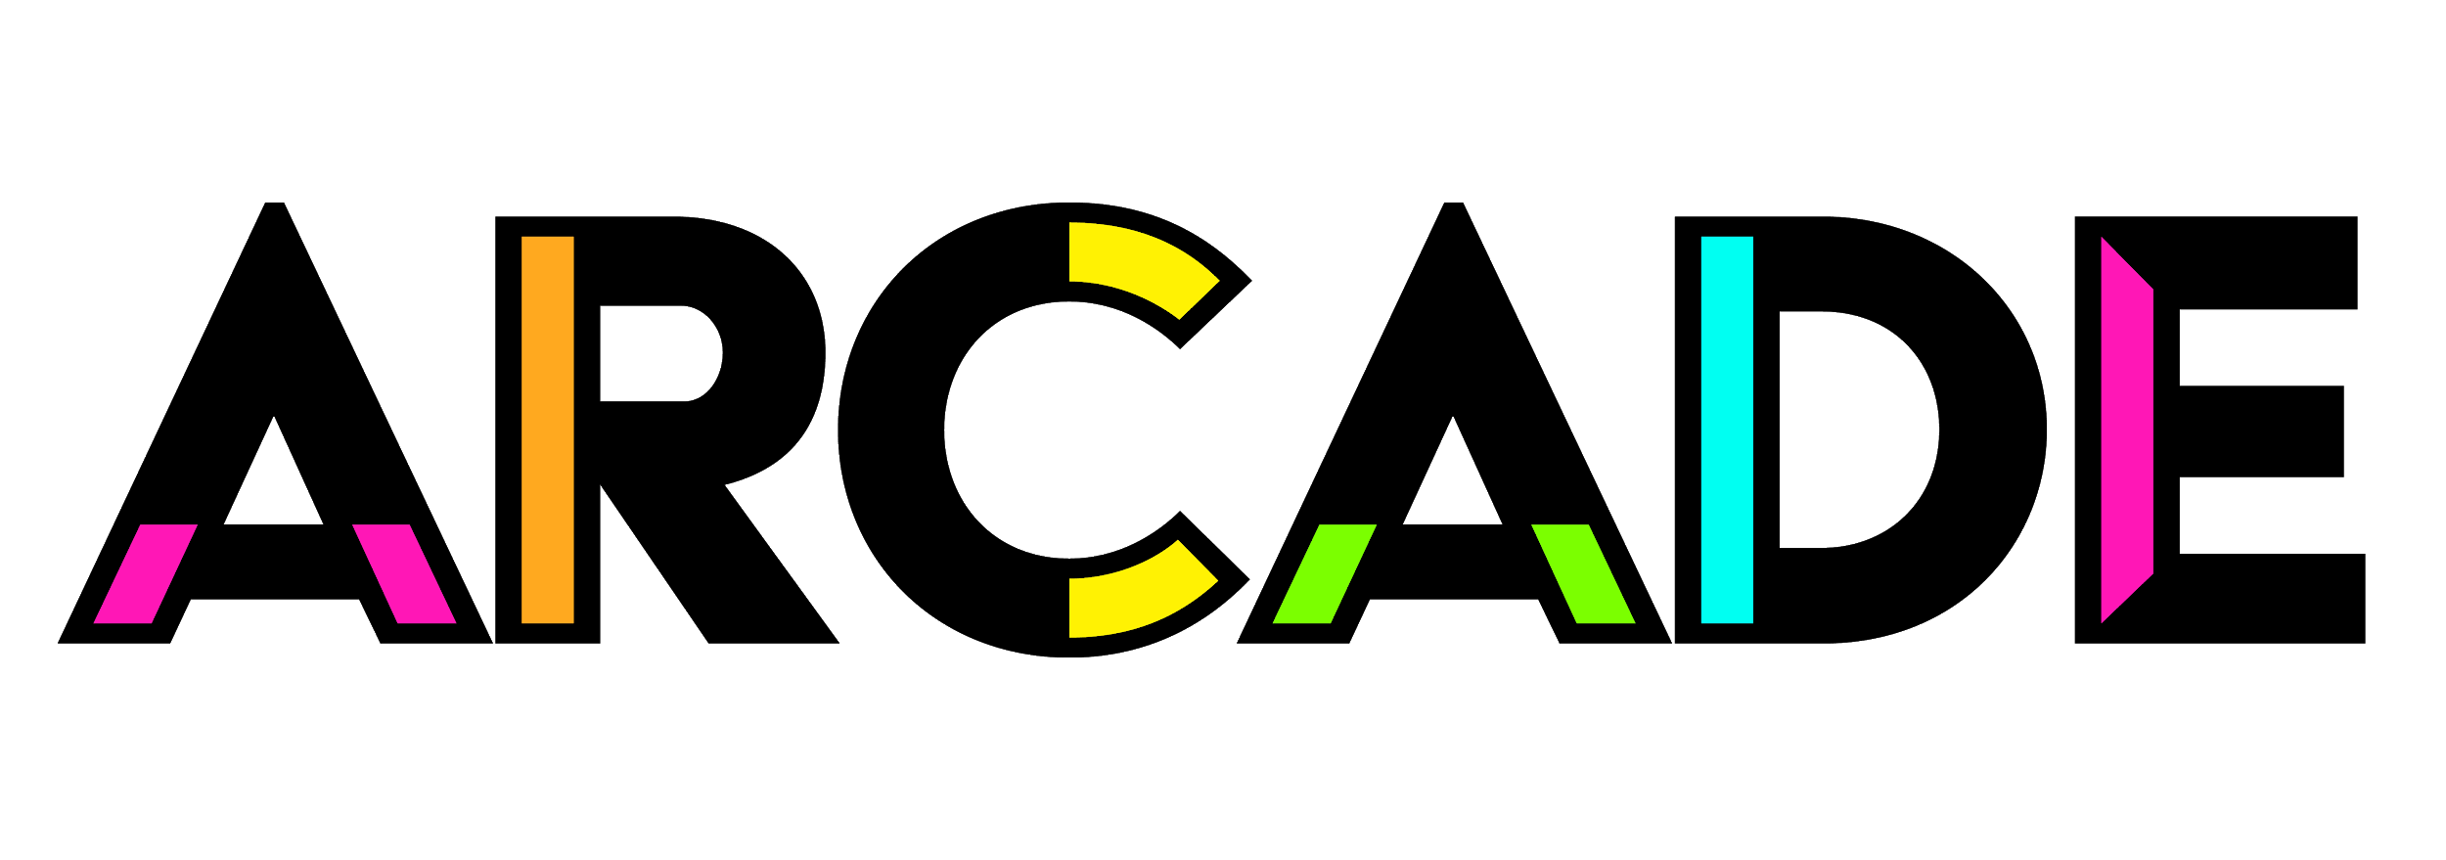
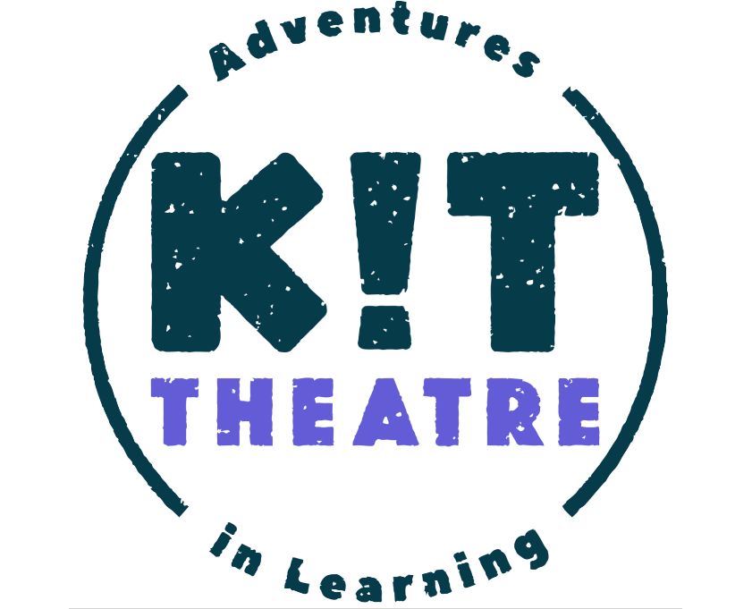
Role: Immersive Artist / Facilitator
Application closing date: 9am, 12th April 2021
Interview timeframe: w/c 26th April 2021
Contract type: 2 days prep & planning / 5 days delivery freelance
Fee: 7 days @ £200, £1,400
Delivery dates: 28th June - 2nd July 2021
Location: Scarborough

About Us
KIT Theatre creates immersive theatre for, by and with young people. They create interactive stories which erupt in schools, theatres and museums, combining theatre and game mechanics. A short film about KIT's work can be found here.

ARCADE is a producing company based in Scarborough who make incredible arts experiences happen with communities.

KIT work nationally with their programme of Adventures in Learning and this summer are launching a project called Wardrobes in mainstream Scarborough schools, produced by ARCADE and commissioned by North Yorkshire Library Services and Scarborough Museums Trust. The Springhead Adventure is a bespoke project created through discussions with staff and responses from pupils from Springhead Specialist School.

The role
KIT Theatre & ARCADE are looking for an artist to collaborate on an immersive adventure alongside the inspirational pupils and teachers at Springhead SEND School. You’ll work alongside pupils and teachers and other KIT artists to respond to young people’s ideas as they come to the aid of a lost Olympian time traveller.

The artist will be working alongside KIT’s artistic director Tom Bowtell as part of a week-long residency, working with a diverse range of pupils with a wide range of special educational needs and disabilities. The school has 5 classes and every class will have a different and distinct artistic journey.

This project will emerge organically and responsively over the intensive residency period and will require the creative skills and attitude to embrace this collaborative journey into the unknown.

Skills:
We are interested in meeting artists with a wide range of skills such as:
- actor-musicians confident in improvising songs in the moment
- puppeteers or sensory storytellers experienced in working with young and non-verbal children
- designers or illustrators, able to conjure objects or pictures in response to the ideas young people share
This list is not exhaustive and if you have other skills relevant to the project, we’d still really like to hear from you.

Essential skills:
- Experience of working in a collaborative way with fellow artists, partners and children.
- Can provide examples of working responsively and going ‘off plan’ if necessary.
- Experience of working with young people or people with special education needs and/or disabilities.

Further information:
- Some pupils will have Profound and Multiple Learning Difficulties and experience, enjoy and engage with the world in a very sensory way.
- Other pupils will be full of energy, love outdoor play and flourish in a structure that recognises where and what and what they can bring focus to.
- We are keen to work with artists living within a commutable area from Scarborough and build a local team. If you are not based locally, reasonable travel expenses will be covered.
- Successful applicants will be required to show proof of a DBS issued within 2 years or complete a new DBS application.

Recruitment process
Please send us a CV and a cover letter about your interest in and suitability for the role to info@hello-arcade.com by 9am on 12th April 2021.
We will aim to contact all applicants by the end of the week commencing 12th April. Interviews (via zoom) will be held w/c 26th April.

Access
We welcome applications from people of all backgrounds and walks of life, and we aim to be an inclusive and supportive team to work with.

Please let us know if you require any support to apply, for instance:
- If you prefer this document in an alternative format please email info@hello-arcade.com
- If you prefer to apply for the role in a different format (to that which is described above) please let us know by emailing info@hello-arcade.com to let us know what works for you and we will do our best to accommodate this
We will do our best to support any access requirements you might have to interview, and we will ask you to let us know what these are in the case you are offered an interview.

